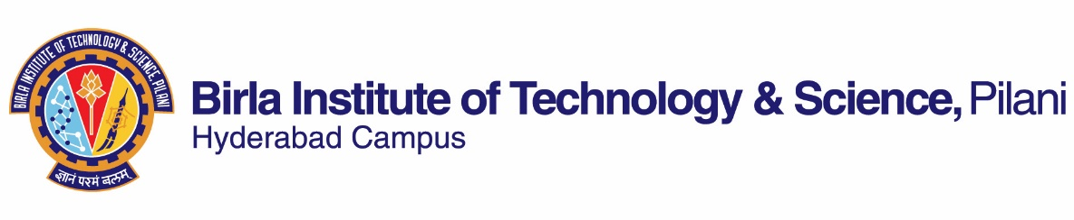

**FIRST SEMESTER 2018-2019**

# Course Handout Part II

Date: 22-07-2019

In addition to part-I (General Handout for all courses appended to the time table) this portion gives further specific details regarding the course.

*Course No.* : ME G532

## Course Title : Machine Tool Engineering

## Instructor-in-Charge : Dr. ARSHAD JAVED

**Scope and Objective of the Course:** The course is intended to instruct and explain the concepts and practices of design, analysis and development of different types of Machine Tools. The course covers introduction to machine tool drives and mechanisms - general principles of machine tool design, regulation of speed and feed rates, design of machine tool structures, prime movers, electrical and hydraulic/pneumatic system, transmission design of guideways and power screws, design of spindles and spindle supports, dynamics of machine tools, control systems in machine tools

The students are encouraged to select seminar topics of current interest and developments in the fields of technology of construction of Machine Tools and present them in the class apart from the regular classroom learning.

**Textbooks:**

1. N.K. Mehta,” *Machine Tool Design and Numerical Control’*, second Edition, Tata McGraw Hill book Company, (2011) [1]

**Reference books**

1. S. K. Basu, and D. K. Pal, “*Design of Machine Tools”,* Oxford & IBH Publication Co Pvt Ltd, New Delhi (1995) [2]
2. A.B. Chattopadhyay, “Machining and Machine Tools” Wiley-India (2011) [3]
3. Suk-Hwan Suh, Seong-Kyoon Kang, Dae-Hyuk Chung, Ian Stroud, “*Theory and Design of CNC Systems*”, Springer-Verlag London Limited

**Course Plan:**

|  |  |  |  |
| --- | --- | --- | --- |
| **Lec. No.** | **Learning objectives** | **Topics to be covered** | **Ref. [book]-Ch.** |
| 1-3 | Enable the student to, Select the design parameter for MT, classify MT*, select proper mechanism mechanisms and methods for designing MT | Fundamentals of Machine Tool Design,  Design Considerations, General requirements, Power drives and transmissions | [1]-1,  [3]-1,2  [2]-2  Class notes |
| 4-11 | Student will be able to design the gear box for a given MT | Aim of speed regulation in MT, Design of stepped drives, i.e. gear box, feed box | [1]-1,2  [2]-3,4 |
| 12-14 | Student will be able to explain the working principle of step less drives, and select them based on application parameters | Objectives of steep less speed regulation, face plate Variators, cone Variators and modern step less speed Variators | [1]- 2  Class notes |
| 15-19 | Student will be able to classify, select and explain the working principle of various electrical drives | Prime movers for MT: Electrical drives, types, working principle, and selection | [1]-1,  [2]-12,13, [3]  Class notes |
| 20-24 | Student will be able to explain the working principle and design a Hydraulic/Pneumatic system for MT | Hydraulic and Pneumatic drives and transmission systems for MT, essential components, development of circuits and trouble shooting | [1]-1,  [2]-12, 13  Class notes |
| 25-28 | Student will be able to classify and design different types of guide ways, beds, tables and columns | Design of machine tool guide ways, beds, tables and columns | [1]-3,  [2]-6,7 |
| 29-30 | Student will be able to design a power screw spindle for a MT | Design of power screws, and spindle units | [1]-4,  [2]-8, 9 |
| 31-32 | Student will be able to design spindle and bearings | Bearings and lubrication in machine tools | [1]-5,  [2]-10 |
| 33-37 | Student will be able to explain the working principle and classify electrical and hydraulic control systems | Control system for MT: Electrical and Hydraulic control systems | [1]-7  [3]-5 |
| 38-40 | Student will be able to identify and evaluate the different dynamic effects of a MT | Dynamics of Machine Tools, Vibrations and dynamic rigidity | [1]-6,  [2]-16, 23 |
| 41-42 | Student will be able to importance design features of CNC machine and select modern machine tools for intended application | Recent developments in machine tool design, Design of CNC machines and selection | [2]-17, [3]  Class Notes |

***\*MT: Machine Tool***

**Evaluation Scheme:**

|  |  |  |  |  |
| --- | --- | --- | --- | --- |
| **Component** | **Duration** | **Weightage (%)** | **Date & Time** | **Nature of Component** |
| Mid semester Test | 90 Min | 20 | 30/9 , 09:00 – 10:30 AM | CB and OB (min 10% weightage on OB)** |
| Quiz | --- | 10 |  | OB |
| Laboratory | -- | 20 |  | --- |
| Assignments | -- | 10 |  | --- |
| Comprehensive Examination | 3 Hrs | 40 | 04/12 FN | Partial CB and OB(min 20% weightage on OB)** |

***\*\* CB = Closed book, OB = Open Book***

**Practical/Lab session:** Learning and Evaluation components equivalent to regular Practical/Lab session will be covered through assignment and Project work.

**Chamber Consultation Hour:** To be decided based on Timetable.

**Notices:** All notices will be put up on CMS only.

**Make-up Policy:** Make-up will be given with prior concern and genuine reasons only.

**Academic Honesty and Integrity Policy**: Academic honesty and integrity are to be maintained by all the students throughout the semester and no type of academic dishonesty is acceptable.

**INSTRUCTOR-IN-CHARGE**